$1350.00
IN PRIZES
Mt Waverley Bowling Club
The Arthur Barton Shield
2 Bowl Triples Tournament.

Wednesday 23rd October 2019
PRIZES
WINNER $780.00 per team
RUNNER-UP $300.00 per team
1ST, 2ND & 3RD GAME WINNERS $90.00 per team
(Overall Winners and Runner-up Teams excluded)

Entry $75.00 per team Entries close Wednesday 16th October Three games each of 13 ends - 10:00 am start - Morning tea & Lunch provided
For further information contact Jim Fary on 0402073531 or Richard Coleman on 9885 8007

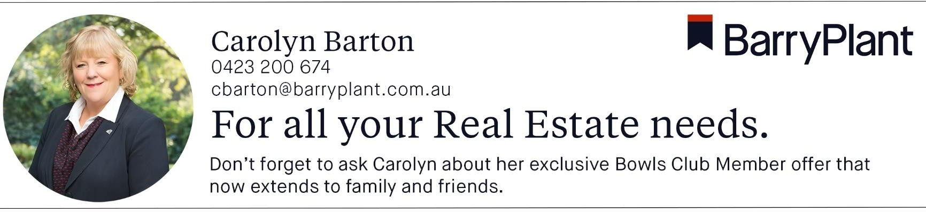
Proudly Sponsored by
.
ARTHUR BARTON SHIELD TOURNAMENT ENTRY: WEDNESDAY 23rd October 2019
Name: _ Phone:

Address: P/Code:

Email address:

Skip:

2nd Lead

Enclosed is $75.00 cheque or EFT Payment to BSB 063-151 A/C 00410190
Payment on the day will also be acceptable

MT WAVERLEY BOWLING CLUB P O BOX 2081 MT WAVERLEY VIC 3149
Return to
OR

TOURNAMENT BOX IN THE CLUBHOUSE

