Mt Waverley Bowling Club
Progressive 2 Bowl Triples Tournament
sponsored by Ryman Healthcare

2019/20 | First Wednesday of the month  2nd Oct, 6th Nov, 4th Dec, 5th Feb, 4th Mar, 1st Apr
Games start at 10:00 am - BYO lunch. Play will be 3 games of 13 ends each day.
Coffee, tea and biscuits will be served on arrival and at the luncheon break.
Entry Fee is $30 per team per month

$3000
Prize Money
Daily winner prize  Daily runner up prize  Games 1, 2 & 3 winner prize  Cumulative winner’s prize  Cumulative runner up prize | $180.00 per team  $90.00 per team  $45.00 per team  $390.00 per team  $180.00 per team

For more information contact Jim Fary on 0402 073 531 or Richard Coleman on 98858007
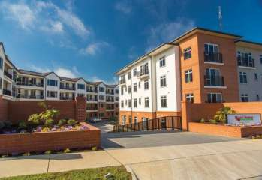
Weary Dunlop Retirement Village
242 Jells Road, Wheelers Hill
Phone Tracey on 8545 1403
New Brandon Park Retirement Village selling now!
6 Brandon Park Drive, Wheelers Hill
Phone Michelle on 9271 3636
For more information on our proposed East Burwood, Coburg, Mt Eliza or Geelong villages please phone Debbie on 1800 288 299
Bowling Club
Progressive 2 Bowl Triples Tournament - Entry Form
Team Name:................................................................................................................................................................................................................. .........................
Address: ............................................................................................................................................................................................................................ ........................
Postcode: ...................................................................... Phone: ................................................................................................................................................
Email: ............................................................................................................................................................................................................................................................
Skip: ......................................................................... 2nd: ................................................................................. 3rd: ..............................................................
 Return completed form to MT WAVERLEY BOWLING CLUB, PO BOX 2081 MT WAVERLEY VIC 3149 - or place in the tournament box in the Clubhouse. Direct Credit to BSB 063-151 Acc: 00410190 (Please show “Surname & Ryman” if paying by Direct Credit) .
Payment of $150.00 before October enters your team for the entire season of 6 games (No refunds). Payment can also be made on the day
Progressive 2 Bowl Triples Tournament
sponsored by Ryman Healthcare

