Mt Waverley Bowling Club

SPONSORED BY

Wednesday February 19th 2020

Roll up 9.15 am
Games commence 9.30 am Lunch provided
3 games of 13 ends

Steve Glasson Invitation 4’s Tournament

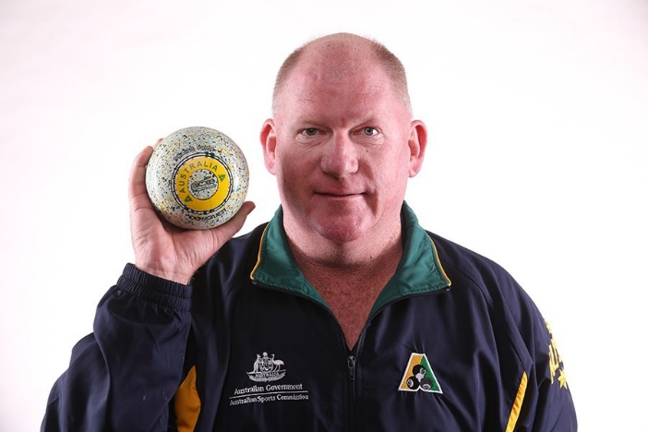

Winners $2,000
Runners Up $800 Winning teams of games 1 to 3 $200
(Overall winning teams excluded)

Entry form over page

SPONSORED BY

STEVE GLASSON TOURNAMENT ENTRY FORM
Name: ........................................................................... Phone......................................

Address...............................................................................................................P/C....................

Lead ..............................................................2nd.............................................................

3rd................................................................Skip................................................................
Email……………………………………………………………………………………………
To secure your entry a full payment of $100.00 per team is required. This is non-refundable for teams withdrawing after 13th. February.
Cheques payable to Mt Waverley Bowling Club, P O Box 2081 Mt Waverley 3149 or place in the Tournament entry box in the foyer of the Clubhouse.
FULL PAYMENT $100.00 ENCLOSED

Direct credit:BSB: 063-151 Account: 00410190 Account description: Your surname + GLASSON To confirm a direct credit please email advice to info@mwbc.com.au and provide team details

