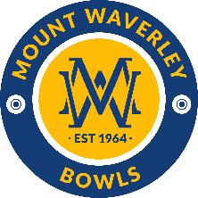
MOUNT WAVERLEY BOWLING CLUB

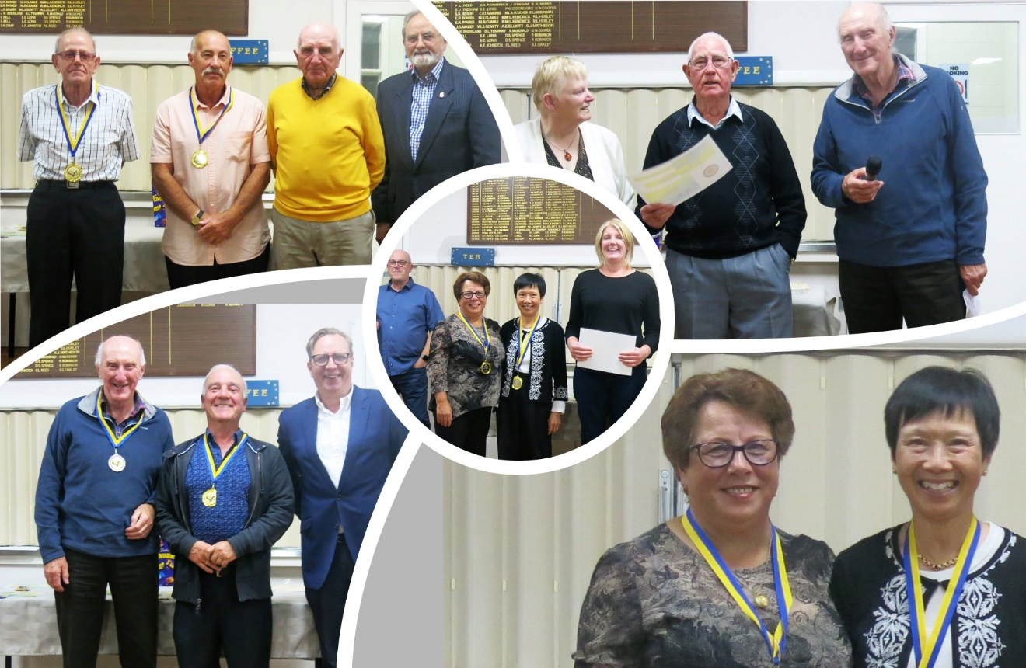

STRATEGIC PLAN 2022 – 2026

May 2022

BACKGROUND
This Strategic Plan updates its predecessor, written in 2021, to take account of changing circumstances.
Unfortunately, 2021/22 continued to be impacted by COVID-19 which had an adverse impact on the Club’s operations and finances. Use of the greens by players and visiting non-profit and business groups was restricted and this had a flow-on effect to income. It also meant that our traditional major tournaments were not able to be held. Despite this, the Club managed to reduce its operating loss of $35,000 in 2020/21 to $10,000 in 2021/22. This was largely due to a significant increase in sponsorship and grant income and the containment of costs.
Looking ahead, we expect the risks of COVID-19 to be substantially reduced and bowling operations to return to ‘near normal’.
As the 2021/22 year ended, inflationary pressures were becoming more evident. Continuation of this trend will put pressure on our revenues to keep up with costs and will reduce the purchasing power of our cash reserves which currently earn interest at a rate well below inflation.
In the year since the 2021 Plan was written, progress has been made in implementing Key Actions identified in that Plan as follows:
- Recruited 15 new members (Robyn to confirm) through a range of marketing initiatives including holding ‘Free Fridays’, erection of new streets signs, preparing a new member Welcome Pack, and developing a simplified process for member applications
- Reduced the Club’s operating loss from the previous year by $25,000
- Strengthened relations with sponsors and recruited 2 new sponsors
- Improved communications, both externally and internally, through a range of initiatives
- Updated the 5-Year Capital Plan
- Continued discussions with the City of Monash regarding renewal of the Club’s current lease
- Funded high priority projects through a range of funding sources e.g., repair of the Clubhouse roof, replacement of the bank surrounds on the Centre Green, and installed energy efficiency measures.
The Club also commenced the planning of a major new initiative - the building of a new Social Deck on the southern side of the Clubhouse.
This Plan builds on the above achievements, identifies Key Issues and Actions for the year ahead and sets out challenging targets for the 5-year planning period.
The Plan is a dynamic document and will be reviewed annually to take account of changing circumstances. Club members and key stakeholders will be advised annually of progress against outcomes and targets set out in the Plan.
The Plan is structured as follows:
- Preparation of the Plan
- Environmental Analysis
- Stakeholder Analysis
- Future Vision
- Key Issues and Actions
- Measures of Success

PREPARATION OF THE PLAN
The preparation of this Strategic Plan has involved a review of the Strategic Plan 2021 to 2025 to account for:
- Material changes in the external environment and stakeholder expectations and the implications of these changes for the Club’s Vision, Key Actions and Key Performance Indicators and Targets
- Progress made over the past year in implementing Key Actions
- The on-going relevance of identified Key Performance Indicators and the achievability of identified Targets.
ENVIRONMENTAL ANALYSIS
An internal analysis of the Club’s strengths and weaknesses and external analysis of opportunities and threats were undertaken and identified the following:
Strengths
- Friendly and welcoming Club
- Well-managed Club
- Convenient location
- Ownership of our building
- Picturesque setting with lovely gardens
- Particularly good bowling facilities
- Strong support for new members
- Attractive venue for social functions
- A welcoming and social club
- Support from the City of Monash
- Good relationships with the Federal and State Members of Parliament
Weaknesses
- Declining and ageing membership
- Difficulty in getting volunteers for committees/working groups
- Difficulties in attracting younger members
- Ageing club house and furnishings
- Ownership of our building which requires on-going maintenance
- Stable financial position, but susceptible to potentially large and necessary capital expenditure
- Trend for sponsors and advertisers to look for a better return on their investment.
Opportunities
- Potential to leverage membership of people about to retire or recently retired
- Potential to leverage membership off existing local clubs e.g., Probus, Waverley Life Activities Club, U3A
- Potential to further extend ‘Free Fridays’ and Corporate Functions to recruit new members
- Potential to have more Clubs/Groups use our facilities on a regular basis
- Potential to encourage local community members to become members
- Potential to create modified opportunities for time poor bowlers
- Potential to encourage the culturally diverse population to take on bowling
- Potential to share resources with other local bowling, sporting, and community clubs
- Potential to grow income from corporate functions
- Potential to encourage more social members through social bowls e.g. Night Bowls
- Potential to access external funding for projects
- Potential to access grant money from all levels of government.
Threats
- Ageing members moving out of active bowling
- Risk that COVID may impact future operations and playing numbers
- Costs are rising faster than our ability to raise revenue
- City of Monash Sports Activity Plan which will set lease payments based on performance goals
- Gen Xs and Ys not solely ‘club motivated’ – want to participate in several sports or pay-for-use
- Replacement of capital assets is increasingly dependent on Council and other Government grants.
STAKEHOLDER ANALYSIS
The Club has a diversity of stakeholders. The principal stakeholders and their expectations are set out in the table below. The expectations of the following stakeholders were confirmed during the year through the following means:
- Corporate Visitors - direct feedback from social functions held over spring/summer of 2021/22
- Expectations of Sponsors - direct feedback from sponsorship drive from July to September 2021.
Stakeholder | Expectations
Playing Members | Strong leadership, organisation and sense of direction, effective communication, responsiveness to issues, value-for-money fees, high standard greens, help with skills development, pennant success, attractive facilities, stimulating social interaction
Social Members | Strong leadership and organisation, effective communication, responsiveness to issues, value-for-money fees, attractive facilities, welcoming, active social program
Visiting Players | High standard greens, attractive facilities, welcoming, friendly, and inclusive Club
Corporate Visitors | Attractive facilities, fun, welcoming, friendly, and helpful Club, competitive function costs
Private Visitors | Attractive, functional, convenient, welcoming, and friendly Club
City of Monash | High community utilisation of Club’s facilities, sustainability of operations, community engagement
Sponsors | Active promotion of products and services, commercial return
Neighbours | Good local citizens

FUTURE VISION
The Future Vision for Mount Waverley Bowls Club is a sustainable, bowls-focused, sporting, and recreational club servicing its members and the wider community.

KEY ISSUES AND ACTIONS
Based on a situational analysis, the following key issues have been identified:
- Declining and aging membership, amongst playing and social members
- Need to turn around the operating loss incurred in 2021/22, focusing particularly on increasing external revenue
- Ageing Clubhouse and furnishings and outdated information systems
- Inadequate member engagement in Club operations
The following actions have been identified as the principal areas of focus to address the key issues above:
- Increase membership, both playing and social members.

- Build on the success of ‘Free Fridays’
- Look to recruit new members based on local opportunities such as participants at external functions, friends and partners of members, Community Hub participants, and sponsors
- Provide more social and flexible bowling opportunities
- Partner with Council on Council-initiated events
- Engage with the multi-cultural community
- Promote a more diverse image of the Club through its Website and Facebook page.

- Restore a sustainable financial position

- Increase revenue from all sources, particularly sponsorship, external functions, and community hub activities
- Continue to contain costs
- Update and prioritize the 5-year Capital Plan for grounds and buildings, and identify possible funding sources
- Continue to apply for grants relevant to the Club

- Improve the Club

- Continue a phased approach to upgrading the interior of the Clubhouse
- Prepare and implement a Shade Plan
- Develop an IT strategy to improve member services and operating efficiency
- Prepare a Plan for an outdoor BBQ area

- Encourage greater engagement of members in Club activities

- Increase the number of members participating in Club activities
- Diversify the workload among members
- Develop guidelines for members who interact with external visitors.
In addition to the above actions, there are several actions from last year’s Strategic Plan that are outstanding and a number that are on-going. These actions will be implemented in the coming year.
Accountability for implementing the above actions will be assigned to individual members of the Committee of Management. In some instances, members may set up Working Groups or Project Teams to assist in completing the task. The Committee of Management will exercise an oversight and co-ordination role in support of the identified actions.
MEASURES OF SUCCESS
The following areas have been identified for measuring the Club’s performance over the 5-year period of the Strategic Plan in achieving its future vision:
- Governance
- Membership
- Bowls
- Greens
- Facilities – condition and utilization
- Reputation/image
- Community involvement
- Finance
Key Performance Indicators for each success area are detailed in the Appendix.

APPENDIX – LIST OF KEY PERFORMANCE INDICATORS
Governance
- Review of relevant policies and compliance with their implementation.
Membership
- Number of new members.
- Increase the ratio of bowling members to social members.
Bowls
- Success of pennant sides – no pennant side to be relegated each year.
- Promote greater diversity in bowls.
Greens
- Maintain status of greens as B+ as inspected by BowlsVic.
Facilities
- 5-Year Capital Plan for grounds and buildings, prioritized, costed and possible funding sources identified, prepared by December.
- Implement planned Club improvements.
Reputation/Image
- Overall satisfaction of key stakeholders.
Community Involvement
- Number of casual visitors using the Club’s facilities each year.
Finance
- Operating cash surplus.
- Liquid reserves.

