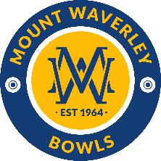
MOUNT WAVERLEY BOWLING CLUB

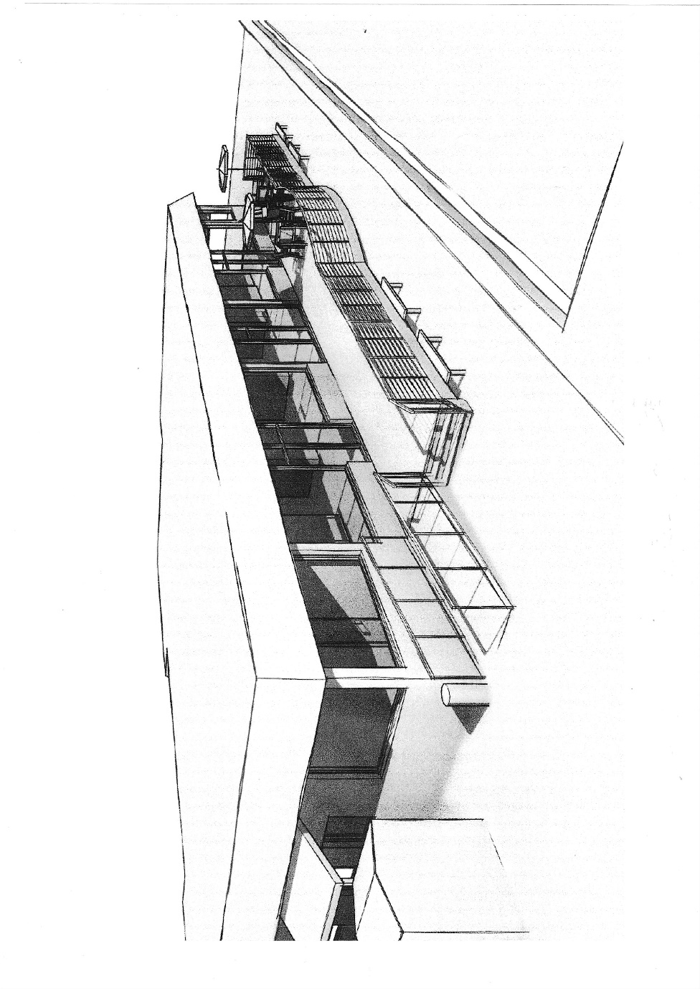

STRATEGIC PLAN 2023 – 2028

September 2023
BACKGROUND
This Strategic Plan updates its predecessor, published in May 2022, to take account of changing circumstances.
Season 2022/23 was the first in the last 3 years to be unaffected by COVID -19 and saw a resumption of normal bowling operations with full utilisation of our two greens and Clubhouse facilities. This resulted in a major turnaround in the Club’s finances from an operating loss of $10,000 in 2021/22 to an operating profit of $10,000 in 2022/23.
The much-improved financial outcome was primarily due to a large increase in external events, continuous rental of our premises by a community-based organisation and tight control of operating, maintenance and administrative costs in a climate of high inflation.
The financial outcome was particularly noteworthy as several improvements to the Clubhouse were able to be completed without drawing down the Club’s financial reserves.
Looking ahead, we expect inflationary pressures will continue to put pressure on our revenues to keep up with costs and will reduce the purchasing power of our cash reserves which currently earn interest at a rate well below inflation.
In the year since the 2022 Plan was written, significant progress has been made in implementing Key Actions identified in that Plan and achieving Key Performance Targets:
- Recruited 13 new members through a range of marketing initiatives including holding ‘Free Fridays’ during the summer bowling season
- Returned the Club to profitability with a capability to fund capital improvements
- Recruited a major new sponsor
- Improved communications, both externally and internally, through a range of initiatives
- Continued discussions with the City of Monash regarding renewal of the Club’s current lease in the context of a Bowls Strategy being developed by Council
- Obtained Planning Approval for the construction of a new social deck on the south side of the Clubhouse
- Funded high priority projects through a range of funding sources e.g., repainting of the Dining Room and Lounge, installation of new blinds in the Dining Room and modern Honour Boards in the Dining Room and Lounge
- Developed a new Club Constitution.
This Plan builds on the above achievements, identifies Key Issues and Actions for the year ahead and sets out challenging targets for the 5-year planning period.
The Plan is a dynamic document and will be reviewed annually to take account of changing circumstances. Club members and key stakeholders will be advised annually of progress against outcomes and targets set out in the Plan.
The Plan is structured as follows:
- Preparation of the Plan
- Environmental Analysis
- Stakeholder Analysis
- Future Vision
- Key Issues and Actions
- Measures of Success

PREPARATION OF THE PLAN
The preparation of this Strategic Plan has involved a review of the Strategic Plan 2022 to 2027 to account for:
- Material changes in the external environment and stakeholder expectations and the implications of these changes for the Club’s Vision, Key Actions and Key Performance Targets
- Progress made over the past year in implementing Key Actions and achieving Key Performance Targets
ENVIRONMENTAL ANALYSIS
An internal analysis of the Club’s strengths and weaknesses and external analysis of opportunities and threats were undertaken and identified the following:
Strengths
- Friendly and welcoming Club
- Well-managed Club
- Convenient location and parking
- Ownership of our building
- Picturesque setting with lovely gardens
- High standard greens
- Strong support for new members
- Attractive venue for social functions
- Good relationships with the Federal and State Members of Parliament.
Weaknesses
- Challenge in getting volunteers for committees/working groups/Club activities
- Challenge in attracting younger members
- Ageing club house and furnishings which requires on-going and often costly maintenance
- Stable financial position, but susceptible to potentially large and necessary capital expenditure requirements
- Trend for sponsors and advertisers to look for a better return on their investment.
Opportunities
- Potential to leverage membership of people about to retire or recently retired
- Potential to leverage membership off existing local clubs e.g., Probus, Waverley Life Activities Club, U3A
- Potential to further extend ‘Free Fridays’ and external functions to recruit new members
- Potential to encourage local community members to become members
- Potential to share resources with other local bowling, sporting, and community clubs
- Some further potential to grow income from external functions
- Potential to encourage more social members through social bowls e.g. Night Bowls
- Potential to access external funding for projects
- Potential to access grant money from all levels of government
- Potential for BV and ERBR clubs to use our resources.

Threats

- Ageing members moving out of active bowling
- Rising costs
- Replacement of capital assets is increasingly dependent on Council and other Government grants.
STAKEHOLDER ANALYSIS
The Club has a diversity of stakeholders. The principal stakeholders and their expectations are set out in the table below. The expectations of the following stakeholders were confirmed during the year through the following means:
- Visiting Players – direct feedback from competition over the 2022/23 bowling season
- Corporate Visitors - direct feedback from events held over spring/summer of 2022/23
- Sponsors - direct feedback from sponsorship drive held between July and September 2022.
Stakeholder | Expectations
Playing Members | Strong leadership, organisation and sense of direction, effective communication, responsiveness to issues, value-for-money fees, high standard greens, help with skills development, pennant success, attractive facilities, stimulating social interaction
Social Members | Strong leadership and organisation, effective communication, responsiveness to issues, value-for-money fees, attractive facilities, welcoming, active social program
Visiting Players | High standard greens, attractive facilities, welcoming, friendly, and inclusive Club
Corporate Visitors | Attractive facilities, fun, welcoming, friendly, and helpful Club, competitive function costs
Private Visitors | Attractive, functional, convenient, welcoming, and friendly Club
City of Monash | High community utilisation of Club’s facilities, sustainability of operations, community engagement
Sponsors | Active promotion of products and services, inclusion in social functions
Neighbours | Good local citizens

FUTURE VISION
The Future Vision for Mount Waverley Bowls Club is a sustainable, bowls-focused, sporting, and recreational club servicing its members and the wider community.
KEY ISSUES AND ACTIONS
Based on a situational analysis, the following key issues have been identified:
- Recruitment and engagement of members
- Player development
- Enlistment of volunteers
- Maintenance of financial sustainability
- Modernisation of ageing facilities
- Improved communications
- Celebration of the Club’s 60th anniversary
The following actions have been identified to address the key issues above and to improve the overall performance of the Club:

- Recruit and Engage Members

- Engage a social media expert to build on the success of ‘Free Fridays’
- Encourage sponsor staff to participate in Free Fridays
- Engage with the multi-cultural community through current members.

- Improve Bowling Skills

- Develop a systematic approach to coaching players at all levels
- Appoint a Development Co-Ordinator and hold regular training sessions for players wanting to improve their skills.

- Increase the Number of Volunteers

- Encourage more volunteers to support corporate functions and coaching and publicly recognize their efforts.

- Maintain Financial Sustainability

- Strengthen the capital planning process and integrate with the annual budget planning process.

- Improve Club Facilities

- Build the planned social deck within budget and on time
- Upgrade the Clubhouse interior in accordance with the Clubhouse Improvement Plan
- Progressively implement the Shade Plan.

- Improve Communications

- Appoint a Communications Co-Ordinator
- Automate and progressively transition away from hard copy communications, bookings and volunteering
- Investigate the use of mobile phones in delivering Club communications.

- Celebrate the Club’s 60th Anniversary

- Plan and implement relevant activities.
In addition to the above actions, there are several actions from last year’s Strategic Plan that are outstanding and a number that are on-going. These actions will be implemented in the coming year.
Accountability for implementing the above actions will be assigned to individual members of the Committee of Management. In some instances, members may set up Working Groups or Project Teams to assist in completing the task. The Committee of Management will exercise an oversight and co-ordination role in support of the identified actions.
MEASURES OF SUCCESS
The following areas have been identified for measuring the Club’s performance over the 5-year period of the Strategic Plan in achieving its future vision:
- Governance
- Membership
- Bowls
- Greens
- Facilities
- Reputation/Image
- Community Involvement
- Finance
Key Performance Indicators for each success area are detailed in the Appendix.

APPENDIX – LIST OF KEY PERFORMANCE INDICATORS
Governance
- Compliance with current policies and statutory obligations.
Membership
- Number of new members.
Bowls
- Success of pennant sides.
- Diversity in bowls and administration.
Greens
- Maintenance of status of greens as B+ when inspected by BowlsVic.
Facilities
- 5-Year Capital Plan for grounds and buildings, prioritizing projects, prepared by December each year
- Implementation of planned Club improvements.
Reputation/Image
- Overall satisfaction of key stakeholders.
Community Involvement
- Number of casual visitors using the Club’s facilities each year.
Finance
- Operating cash surplus
- Liquid reserves.

