Members Handbook 2023-2024

‘The Friendly Bowls Club’

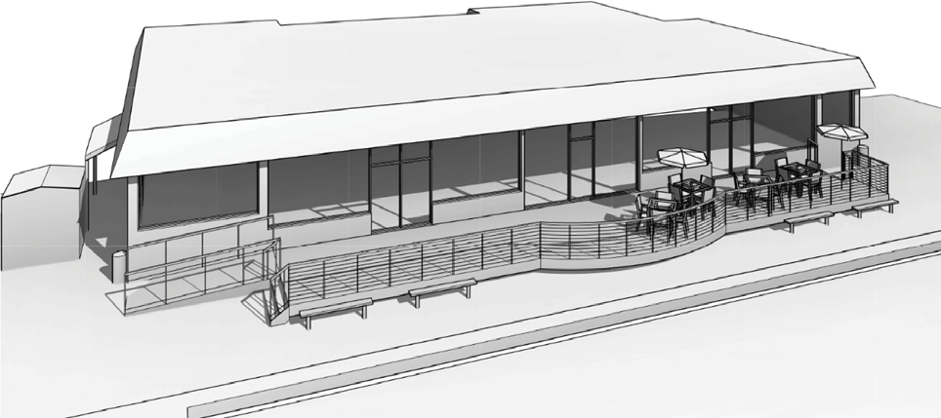
Concept Design of Club’s New Social Deck

MOUNT WAVERLEY BOWLING CLUB INCORPORATED
A0008918F
Cnr. Alvie Road & Wadham Parade MOUNT WAVERLEY 3149

MOBILE: 0478 952 026
CLUBHOUSE PHONE: 9807 9506
EMAIL: info@mwbc.com.au WEBSITE: www.mwbc.com.au

LIFE MEMBERS
Barbara Dance Bruce Kendrick Max Beattie
Graeme Matheson Jim Fary
John Bridgland Ken Johnston Norma Wilkinson Peter Armstrong
Robin Matheson

CONTENTS
PAGE OFFICE BEARERS, SUB COMMITTEES & TEAMS 5
COMMITTEE MEETINGS 8
COACHING 8
PENNANT PLAYING TIMES 8
CLUB RULES & POLICIES 9
GREEN ETIQUETTE 9
HEAT POLICY 10
MEMBER CONTACT LIST 18
CLUB SPONSORS 25

ADVERTISERS
PAGE Jellis Craig Back Cover
Bendigo Bank – Pinewood 1
Herbert King Funerals 11
Leishman Financial Services 13
Le Pine Funerals 12
Lewis and McConnell 16
MST Lawyers 15
Professional Signs…………………………………………… 12
Selwyn Allen Funerals 14
Waverley Floorworld…………………………………………………..17
Wong & Bendixen Pharmacy 15

President Barrie Epstein
Vice President Robyn Beard Secretary David Beard Treasurer Peter McDonald Members Jill Anderson
Ian McLean Howard Rose Richard Sluggett Celia Ware
Bev Wong
Shirley Melissas
Accountant Richard Coleman
Honorary Solicitors MST Lawyers
Auditor Debra Pink
ERBR – Delegates Barrie Epstein
David Beard
Head of Bowls Barrie Epstein
Greens Director Joe Bonnici
Coaches Joe Bonnici
Minh Vo
Weekend Selectors Celia Ware (Chairperson)
Richard Sluggett
Michael Murray
Midweek Selectors Celia Ware (Chairperson)
Richard Sluggett
Thursday 7’s Selectors Barrie Epstein
Umpires Tony Allen
Joe Bonnici
Ernst Espernberger

Measurers David Beard
Robyn Beard
Sarina Bonnici
David Rae
Phil Rosengarten
Minh Vo
Celia Ware
Championship Committee Celia Ware
Alan Sharp
Winter Bowls Doug Oldfield Head of Marketing Howard Rose Sponsorship Team David Beard
Robyn Beard Bruce Bennett Richard Coleman Barrie Epstein Peter McDonald Angus Reynolds Phil Rosengarten Richard Sluggett Maisie Tsoi
Sponsor Database Howard Rose
Grant Applications Jill Anderson

Recruitment, Membership &
New Member Liaison Robyn Beard
Ian McLean Minh Vo
Community Hubs Robyn Beard
Website Barrie Epstein Facebook Jill Anderson Newsletter Richard Sluggett Calendar Barrie Epstein
Robyn Beard
Head of Operations Ian McLean
Safety Officer Ian McLean
House & Maintenance Graeme Robinson
David Hutchinson Bev Wong

Ground & Surrounds David Rae
Jill Anderson Bernie Brennan Richard Horban Barry Jarred Lindsay Markham Angus Reynolds
Phil Rosengarten
Licensee Minh Vo
Bar Committee Minh Vo (Chairperson)
Peter Harney Ian McLean
Providor Lynda Banbury
Club Social Events Bev Wong
Sarina Bonnici Michelle Chan Connie Epstein Alan Sharp
Corporate Events Coordinator Barrie Epstein
Minh Vo
Members Database David Beard
Membership Records Bruce Kendrick
Almoner Bernie Brennan
Uniform (Club Tops) Jill Anderson

SCHEDULED DAYS & TIMES FOR MONTLY COMMITTEE MEETINGS*
Committee of Management: 2nd & 4th Thursday 3:00 pm
Executive Committee: Weekly Monday 8:30am
Weekend Pennant Selectors: Monday 10:00 am
Midweek Pennant Selectors: Tuesday 3:00 pm

COACHING
Individual coaching is by specific request of a member and arranged between the player and coach concerned. Coaching is available all year. Please note that some coaches may not be available during the winter recess.
COACHES – By appointment

Joe Bonnici | 0424 280 580
Minh Vo | 0439 388 096

PENNANT PLAYING TIMES
Weekend Pennant Season – play commences 1:00pm Pre pennant practice – 11:30-12:30
Midweek Pennant Season – play commences 10:30am Pre pennant practice –9:00-10:00

Thursday Pennant Season - play commences 10:30am
Pre pennant practice –9:00-10:00

ACCESSING CLUB RULES, POLICIES AND FURTHER INFORMATION
The MWBC Constitution, By-Laws, Policy & Procedures can be accessed from the Club web site www.mwbc.com.au. The By-laws include the Club’s Selection Policy and Club Championship rules.

ETIQUETTE ON THE GREEEN
Bowls is a friendly game. Consideration for others, courtesy and good sportsmanship add charm to a skillful and rewarding sport.
All Mt Waverley greens and surrounds are smoke free.

HINTS FOR MEMBERS:
- Do not walk across the rinks when play is in progress.
- Do not play before your opponent’s bowl has come to a stop.
- Avoid dropping (dumping) bowls.
- Stand clear of the head until the shot has been decided, then help move the bowls well behind the mat for the start of the next end.
- After delivering your bowl, do not step backward. Return to a position at least two metres behind the mat when your bowl comes to rest.
- Stay alert and be ready to play when it’s your turn.
- Avoid moving about the head when a player is about to deliver a bowl.
- When standing at the non-bowling end avoid obstructing the line of sight to the boundary pegs
- Move down the centre of your rink when changing ends.
- Remain silent when a player is about to deliver a bowl.
- Know and understand the Laws of the game.
- Consult an umpire if unsure.
- Due to Covid safety directives, do not pick up another player’s bowls.

DO
- Give full support to all members of your team.
- Applaud good shots and generally encourage your own players.
- Play for the TEAM, not your individual success.
- Play the shot you are asked to play by your Skip without questioning it.
- Notify your opponent if unable to keep an appointment for any club game.
- Dress correctly
- Understand that the Umpire’s decision is FINAL.

HEAT POLICY
Bowls Victoria Events
For Bowls Victoria events or club events being conducted under Bowls Victoria conditions, the heat policy as set out by Bowls Victoria in the Conditions of Play applies.
The temperature for Weekend and Midweek Pennant is 36 degrees Celsius at the Scoresby Weather Station.
Club In-House Policy
For other Club events, players will conform to the Club “in- house” policy set out below.
- Play shall not commence:
  - If the temperature at the Scoresby Weather Station is 34 degrees Celsius or more at the scheduled commencement time, play will be postponed for up to 1 hour.
  - If the temperature fails to fall below 34 degrees Celsius within I hour of play being postponed, the event is abandoned.
- Play shall not continue after an event has commenced due to excessive heat:
  - If the temperature at the Scoresby Weather Station reaches 34 degrees Celsius or more at any time after play commences, play will be suspended for up to I hour.
  - If the temperature fails to fall below 34 degrees Celsius within 1 hour of play being suspended, the event is abandoned.
  - An event shall be abandoned if interruptions cause play to exceed 5 hours from the scheduled starting time.

It is comforting to know there is someone to assist with traditional care and respect when you become involved in arranging (or pre- arranging) the funeral of a family member or friend.
Herbert King, a proud family and Australian company since 1853.

24 HOUR SERVICE ALL AREAS
364 Warrigal Road ASHBUR- TON
PHONE: (03) 9885 5288

For assistance or advice on funerals, pre-arranged or pre-paid funeral plans, please call Ian Proudlock any time
(03) 8587 5700
388 Springvale Road,
Glen Waverley, 3150
lepinefunerals.com.au

L4 / 295 Springvale Rd Glen Waverley Ph 9561 9699 E: info@leishmans.com.au www.leishmans.com.au

In 2020 we celebrate our 35th Anniversary.
That’s 35 years of professional advice to local families.

Through all markets, bull and bear, LFS is always there.

For Aged Care advice, Retirement Income advice, Centrelink advice and more.

Phone now for your complimentary, no obligation appointment. 9561 9699

LEISHMAN FINANCIAL SERVICES
AFSL, No. 227747.
ABN 76074579749

Selwyn & Geoff Allen have been serving the local Mount Waverley community for over 20 years.
Along with their experienced staff, they offer personal, dependable service with over 100 years combined experience.
Secure Pre-Paid and Pre-Arranged Funerals

Selwyn, Wendy and Geoff
T: (03) 9888 1672
E: enquiries@selwynallenfunerals.com.au W: www.selwynallenfunerals.com.au

NOTES

SUPPORT THE BUSINESSES THAT SUPPORT OUR CLUB

Bendigo Bank – Pinewood
Bowling Club Insurance Brokers – BCIB De Bortoli
Herbert King Funerals
Hamilton Place Travel
Jellis Craig Monash
Kingston Funerals Leishman Financial Services Le Pine Funerals
Lewis & McConnell – Optometrists Mason Sier Turnbull Solicitors – MST PK Free-Range Meat
Professional Signs
Rogerson Kenny – Accountants
Ryman Healthcare
Selwyn Allen Funerals
Soundfair
Waverley Floorworld
Wong & Bendixen Pharmacy

Scan for
your property appraisal today

The Heart of Monash Property

Real advice. Real results.
Really good coffee.

Jellis Craig. The heart of Monash property.

Jellis Craig Monash
280 Stephensons Road, Mount Waverley Troy Riley
P 0419 897 658
E TroyRiley@jelliscraig.com.au
jelliscraig.com.au

