MOUNT WAVERLEY BOWLING CLUB

60th Anniversary Tournament
MWBC 60th Anniversary Tournament
Sponsor Jellis Craig
Prizemoney $1800

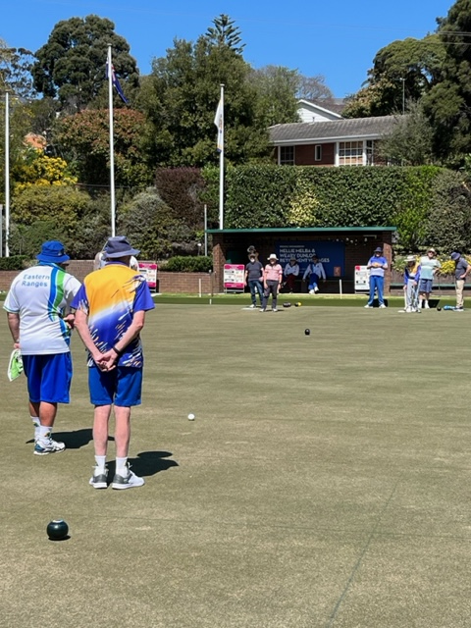

Saturday13 April 2024
Open to players in Division 2 and below

Games start at 10:30 am – BYO lunch.
Play will consist of 2 games of 2 bowl triples each of 15 ends.
Coffee, tea, and biscuits will be served on arrival and at the luncheon break.
Entry costs $45.00 per team. Conditions of play will be outlined at 10.15am.

Highest 1st Round winner $300.00 per team

Highest 2nd Round winner $300.00 per team

Cumulative winner’s prize $750.00 per team

Cumulative runner up prize $450.00 per team

For more information visit our website at www.mwbc.com.au or email special requests to info@mwbc.com.au

ENTRY FOR Jellis Craig Anniversary Tournament 2 BOWL TRIPLES

Name: ..............................................................................

Address: .......................................................................................................................................

Post Code: ...................... Phone: ..........................................

Lead .........................................2nd .........................................Skip ............................................

Direct Debit to Mount Waverley Bowls Club
BSB 633000 Account Number 146872999
Please show Surname if paying by Direct Debit)

